Code Review: I2310290
Reviewer: James Wood
Date: November 30, 2023

Bugs
- These lines exist because the InvoiceDetails class does not currently have a StockUOM field. It only has the StockUOMID field:
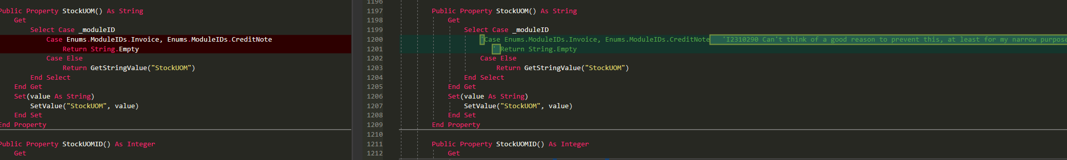
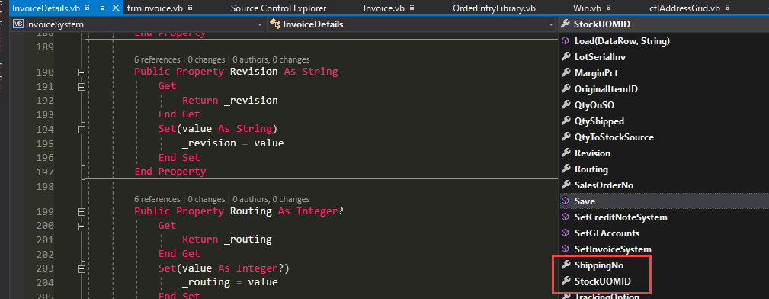
- I’m not too sure about this, so I will ask the question, it seems possible that the OrderUOM could be different than the “expected” OrdUOM:
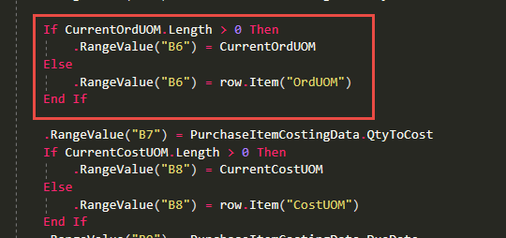
But it looks like this potential difference is not taken into account when running ConvertUOM:
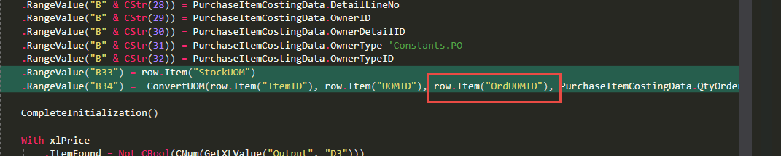
Where does “CurrentOrdUOM” come from and should it be used in ConvertUOM? Having asked that, my follow up question is this: is there not already a QtyToStock value available to us from the source detail itself? Is there a way to get that value in here so we can bypass having to call ConvertUOM?

Preventative Action/Safety
- Likely not possible, but I think this will blow up if any of these columns contain NULL. I suggest using sxGetInt32_2() instead. This line may not be required as per the above notes.
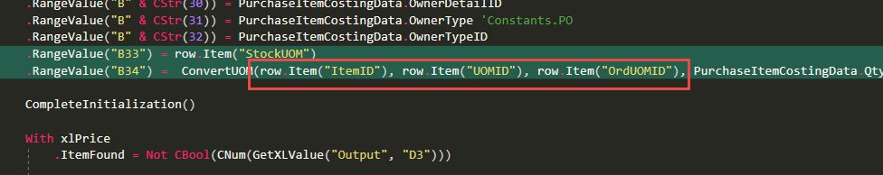

Design/Architecture (Duplication, appropriate project, namespaces, maintainability)

Data Model (Naming, good design, needs index?)

Performance (Minimize DB hits, excessive loops, queries, scalable)

UI (Alignment, naming, standardization, tab order)

Error Handling (Behind events, appropriate parameter checking)

Cleanup (Dispose code, remove handlers, large data objects)

Readability (Well-named variables, methods, clear algorithm, is it understandable)
- For consistency across the system, I suggest reversing the order of the StockUOM and Qty to Stock cells in the Vendor Price List.
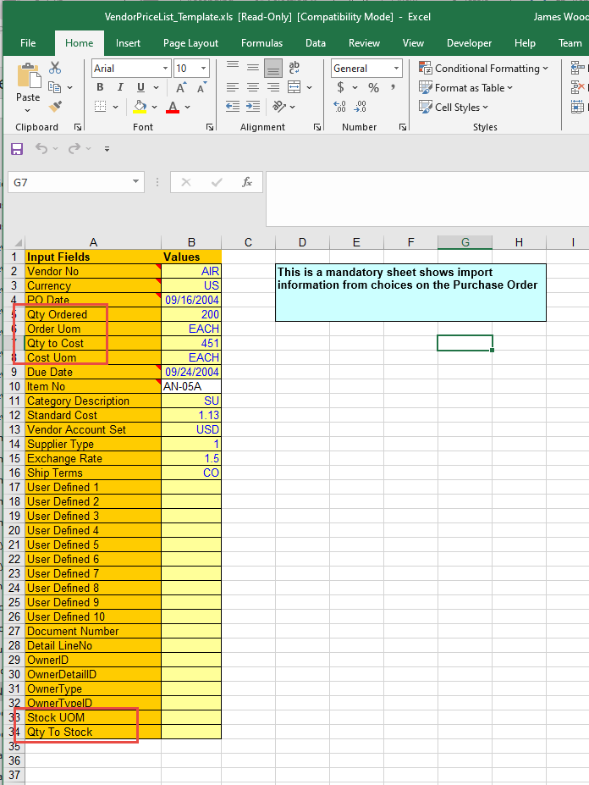
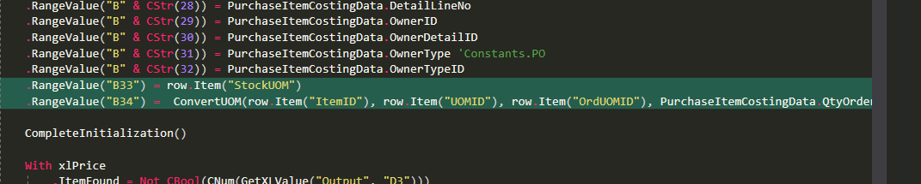

Comments (Useful, explains why rather than how)

Message Boxes (Grammar, spelling, captions, appropriate icons)

Ticket Management (Release Branch?, Testing Notes)

Extras

